

Continuning

Education

Program

Center for Computing and Information Technology

Faculty of Technic University of Indonesia

**PROJECT**

**“ The Hotel Application”**

Created by:

♦ Funny Bintang .K

♦ Melinda Nur Puspita Dewi

♦ Mutia Ayu Dianita

Group : 2

Class : 2SC1 (PNJ)

Faculty : Mrs. Indah Ayu Yuliani ST,MM.

Engineering Center Building 1st floor

Faculty of Engineering University of Indonesia

New Campus UI Depok 16424

**PROJECT ON**

*The Hotel Application*

Developed By

*Name : Funny Bintang .K*

*Melinda Nur Puspita Dewi*

*Mutia Ayu Dianita*

NIIT

**The Hotel Application**

Batch Code : *2SC1*

Start Date : *April 4, 2016*

End Date : *April 11, 2016*

Name Of The Coordinator : Indah Ayu Yuliani ST, MM.

Name Of Developer : *Funny Bintang .K*

*Melinda Nur Puspita Dewi*

*Mutia Ayu Dianita*

Date Of Submission : *April 11, 2016*

NIIT

NIIT

**CERTIFICATE**

This is to certify that this report, titled ***The Hotel Reservation***, embodies the original work done by ***Funny Bintang .K, Melinda Nur Puspita Dewi and Mutia Ayu Dianita*** in partial fulfillment of his course Requitment at NIIT.

***Coordinator:*** Indah Ayu Yuliani ST, MM.

**ACKNOWLEDGEMENT**

We have benefited a lot from the feedback and suggestions given to us by Mrs. Indah Ayu Yuliani and other faculty members. The Project presentation opportunity we have with CCIT-FTUI is a greatchance for learning and professional development. Therefore, we consider ourselves very lucky as we are provided with an opportunity to be a part of it. We are also grateful for having a change to meet so many wonderful people and professionals who led us through this project period.

Bearing in mind, we would like to express our deepest gratitude and special thanks to Mrs. Indah Ayu Yuliani of CCIT-FTUI faculty who is spite of being extraordinarily busy with her duties, took time out to hear, guide and keep us on the correct path and allowing us to carry out our project until completion.

Our Project assignment won’t be as good as it is now without any help, feedback and suggestion that were given to us by our friends within the campus. So, we would also like to say thank you to all of them. We will strive to use gained skills and knowledge in the best possible way, and we will continue to work on the improvements, in order to attain desired carrer objective.

**SYSTEM ANALYSIS**

**System Summary:**

The hotel application is an application which is help the receptionist to save the reservations data in Hotel database. It also can show the reservation data of the hotel reservation.

When the menu shown, in the display there are several things the receptionist must fill with the customer reservation. Each admin has a different panel menu that shown when they’re login. When different admin login, first there is admin Bintang who can access the admin panel which is customer, room and class, also admin Mutia who can access the admin panel. The third is admin melinda who can access the receptionist panel.

First is the admin panel, which is the receptionist must add and fill the customer’s ID, room, and the class of room. After that, the third receptionist of check in and check out panel must add and fill the reservation list of customer’s reservation that available room for the check in. And for the check out, the receptionist can add and fill the check out panel for the customer who wants to leave the hotel. When the customer want to check out, after the receptionist fill the reservation code in check out menu, the total price will shown with the price of room that multiple with days of stay.

**INTERFACE DESIGN FOR THE HOTEL APPLICATION**

*Login Panel*

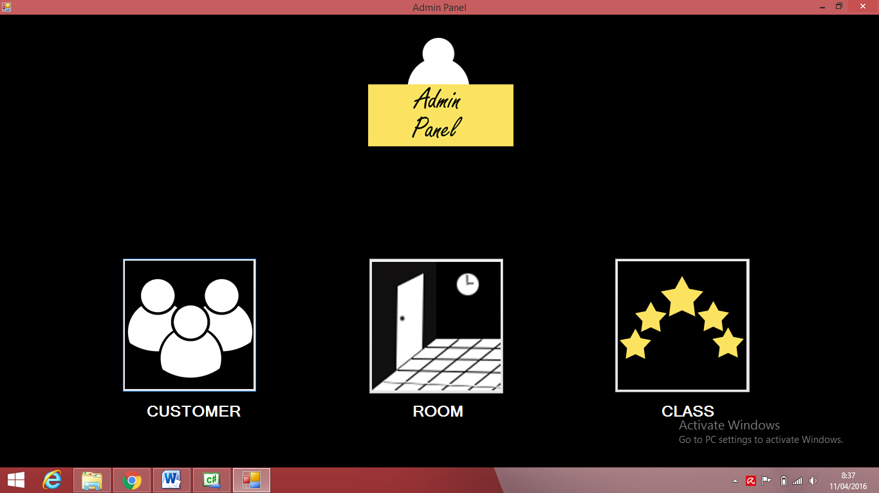

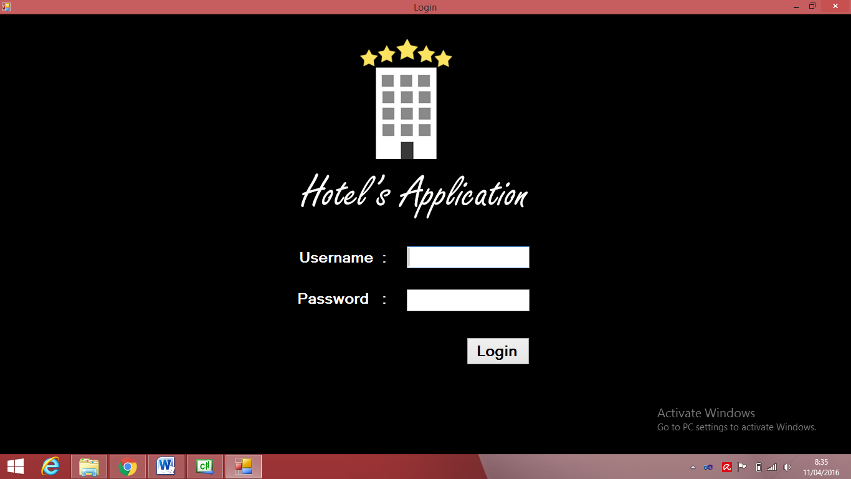

*Admin Panel*

**INTERFACE DESIGN FOR THE HOTEL APPLICATION**

*Customer Shown in Admin Panel*

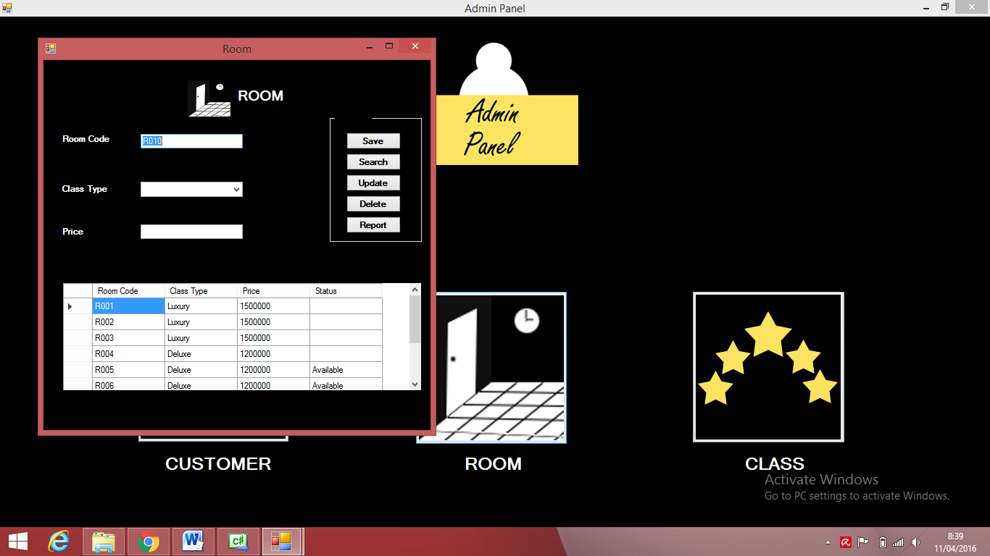

*Room Shown in Admin Panel*

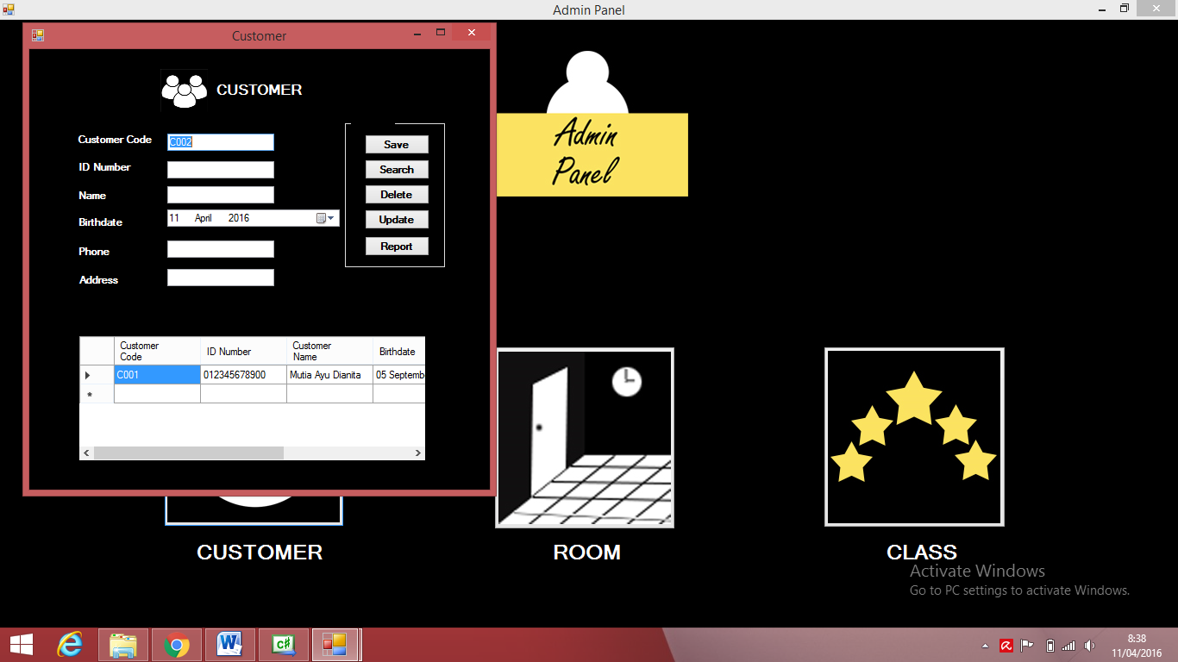

**INTERFACE DESIGN FOR THE HOTEL APPLICATION**

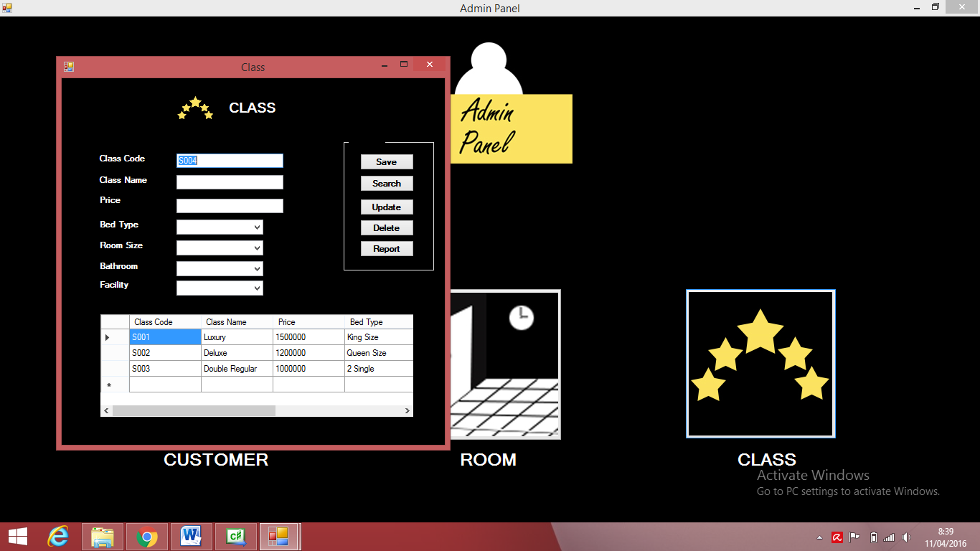

*Class Shown in Admin Panel*

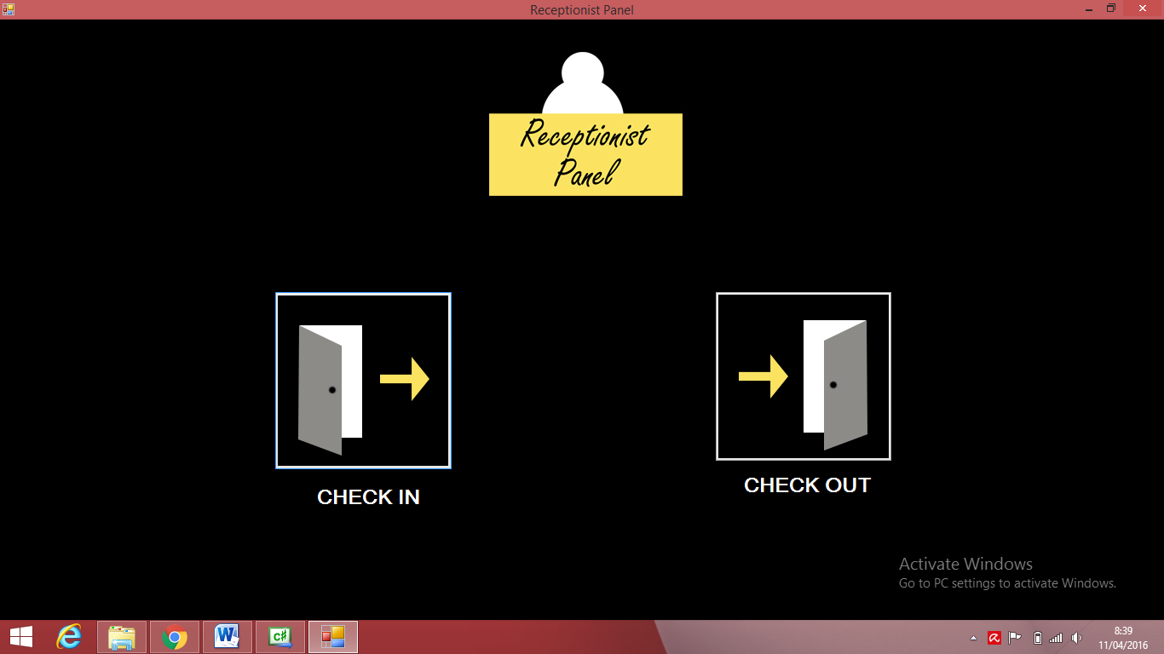

*Receptionist Panel*

**INTERFACE DESIGN FOR THE HOTEL APPLICATION**

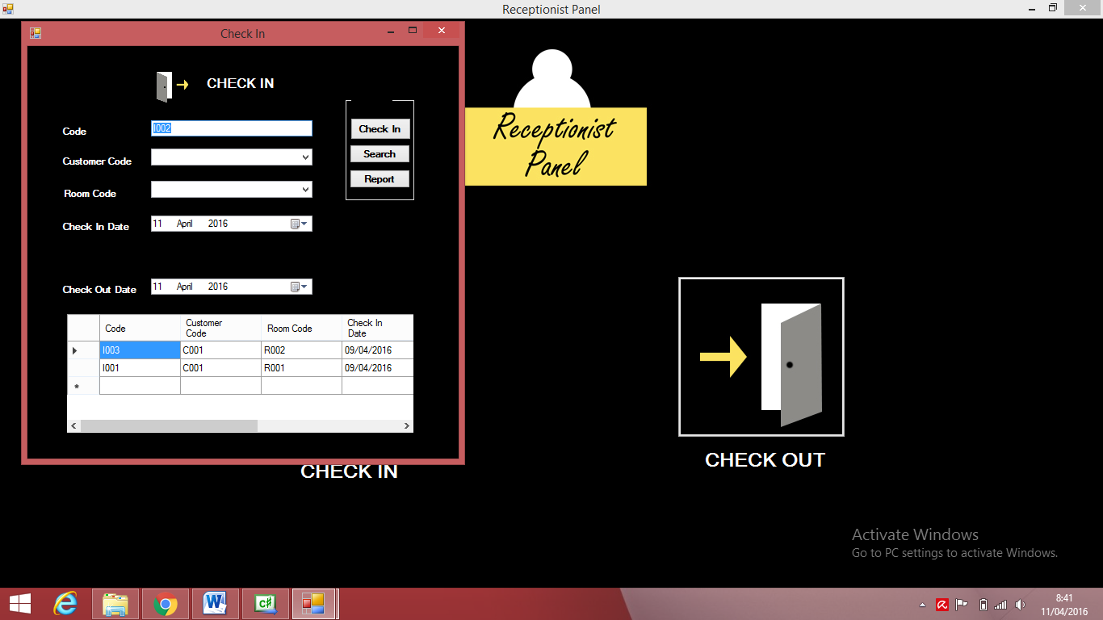

*Check In*

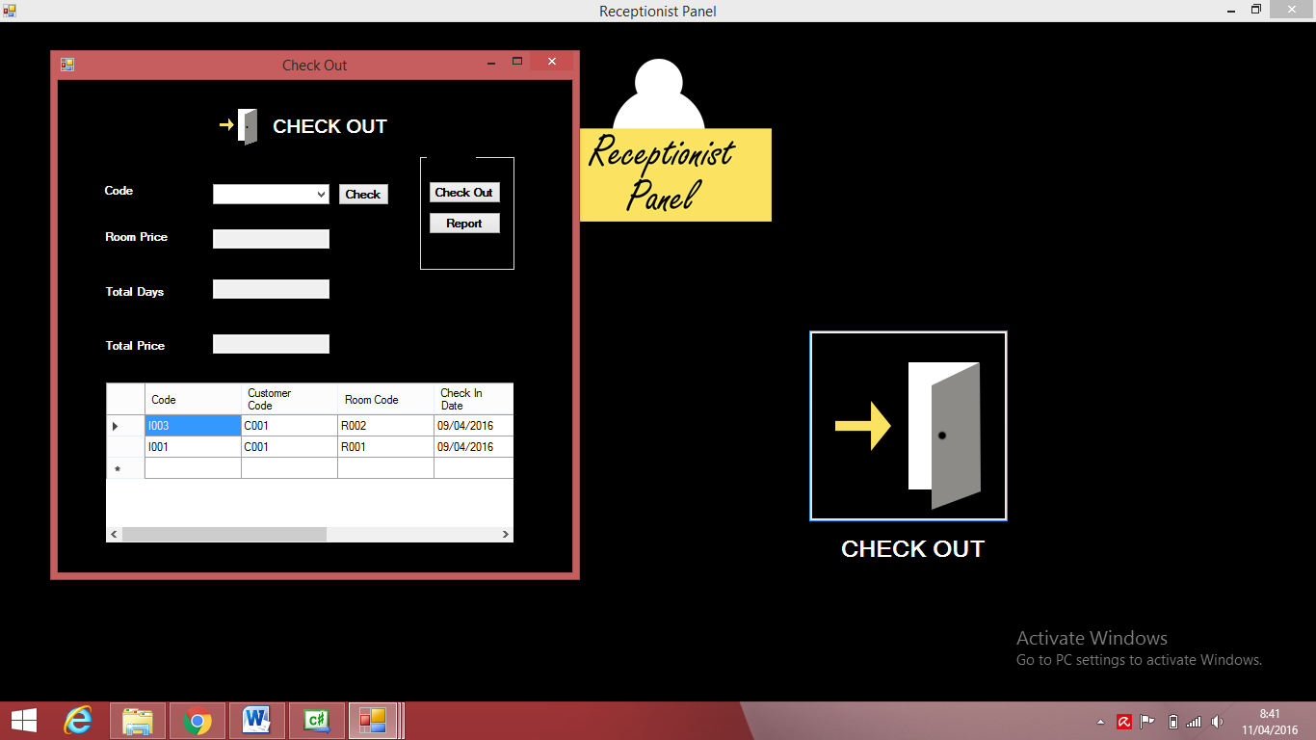

*Check Out*

**INTERFACE DESIGN FOR THE HOTEL APPLICATION**

*Admin login (1)*

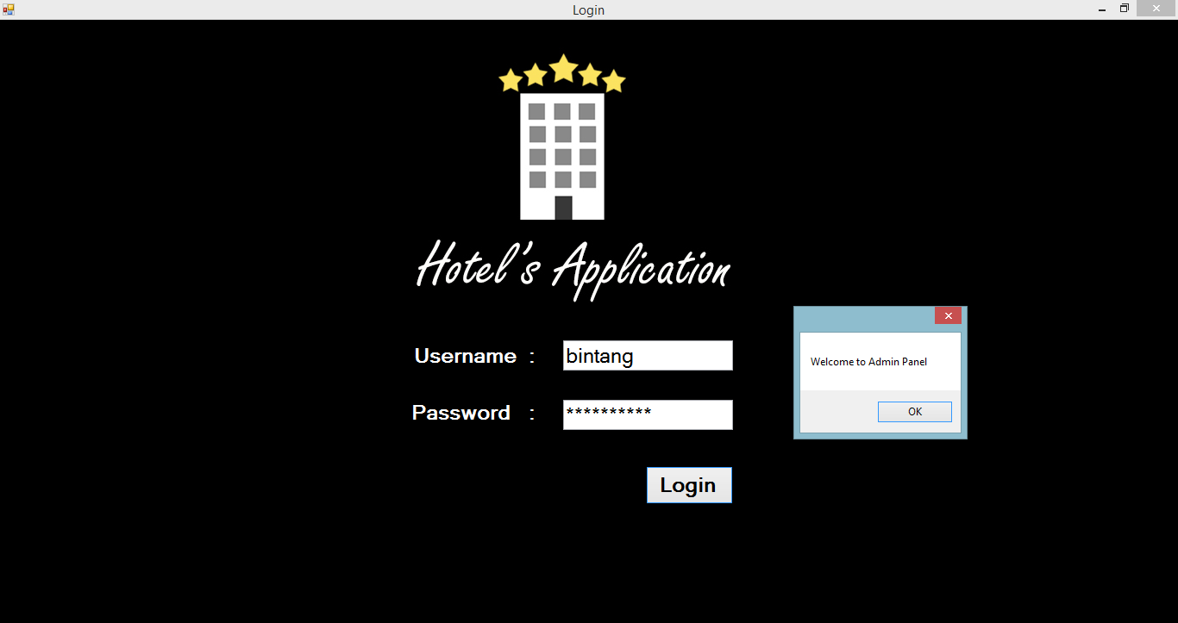

**INTERFACE DESIGN FOR THE HOTEL APPLICATION**

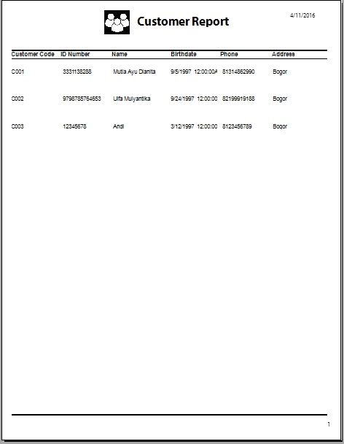

*Crystal Report Customer*

**INTERFACE DESIGN FOR THE HOTEL APPLICATION**

*Crystal Report Room*

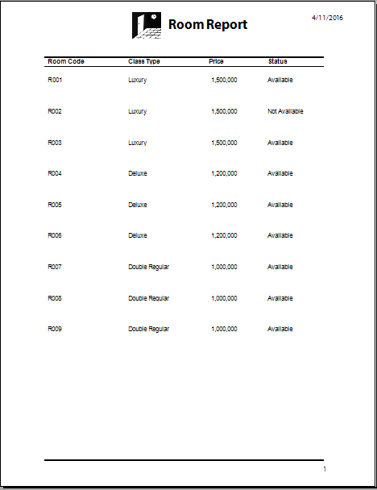

**INTERFACE DESIGN FOR THE HOTEL APPLICATION**

*Crystal report class*

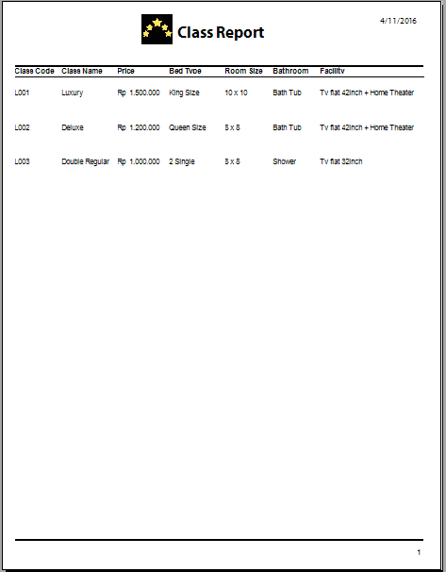

**INTERFACE DESIGN FOR THE HOTEL APPLICATION**

*Login Admin (2)*

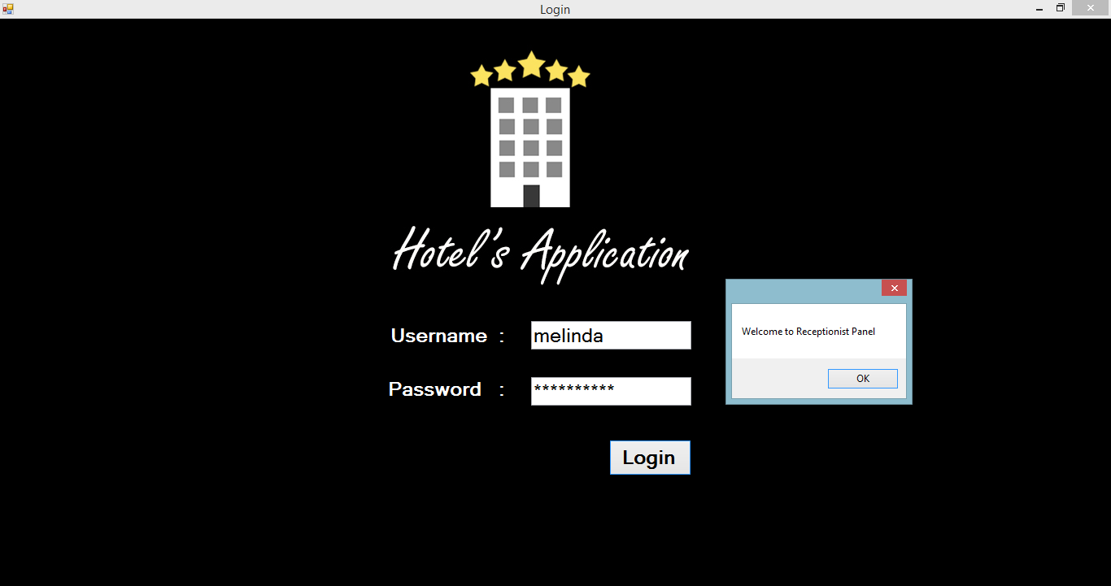

**INTERFACE DESIGN FOR THE HOTEL APPLICATION**

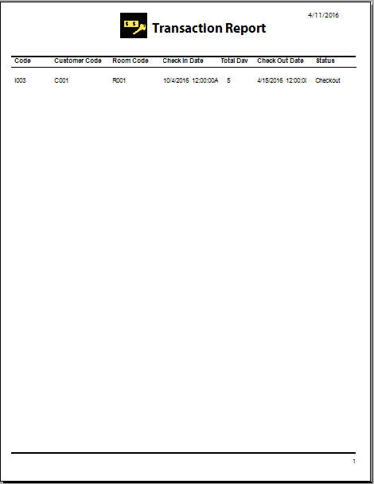

*Crystal Report Check In*

**INTERFACE DESIGN FOR THE HOTEL APPLICATION**

*Crystal Report Check Out*

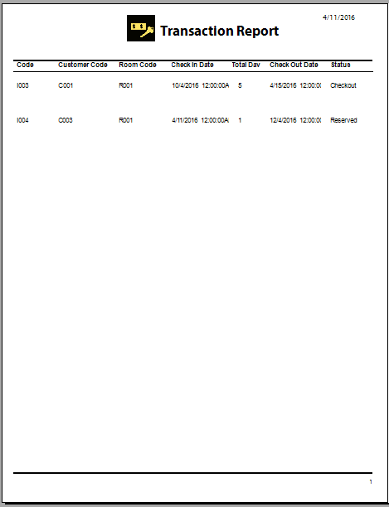

**FORMS OUTLINE**

|  |  |
| --- | --- |
| *Forms Names* | *Description* |
| *Login Panel* | *Form for the administrator to enter the menu* |
| *Admin Panel* | *Form that contains Customer, room and class.* |
| *Customer* | *Form that contains customer data such as customer code, ID number, name, birthdate, phone and address.* |
| *Room* | *Form that contains room data such as room code, class type and price.* |
| *Class* | *Form that contains class data such as class code, class name, price, bed type, room size, bathroom and facility.* |
| *Receptionist* | *Form that contains Receptionist data such as check in and check out.* |
| *Check In* | *Form that contains Check In data such as check in code, customer code, room code, check in date and check out date.* |
| *Check Out* | *Form that contains Check Out data such as check out code, room price, total days and total price.* |

**Problem Encountered**

1. We just learning about Object-Oriented Programming using C#
2. Lack of time
3. Difficult to change the status of room and reservation

**CONFIGURATION**

**Hardware :** IntelR CoreTM i5-5200U CPU @ 2.2GHz Turbo 2.7Ghz, 4.00GB RAM, 500 GB HDD, DVD/RW Super Multi DL drive, VGA nVidia GT820-2GB, Dos, Power 4-cell, 41 Wh Li-ion, HP 14-R202TX.

**Operating System :** Windows 8.1 Pro

**Software :** **-** Microsoft Visual Studio 2010 Ultimate

* Microsoft Word 2010

|  |  |  |
| --- | --- | --- |
| **PROJECT FILE DETAILS** | | |
| **S.No** | **File Name** | **Remarks** |
| 1 | Hotel.sln | Microsoft Visual Studio 2010 Ultimate |